User ID Controlled by Request Parameter – Password Disclosure
Platform: PortSwigger Web Security Academy
Lab Level: Apprentice
Lab Name: User ID controlled by request parameter with password disclosure
Category: Access Control / Sensitive Data Exposure
Author: Chamika Jayasooriya
Field: Cybersecurity / Penetration Testing
Date:

1. Introduction
This document presents a professional security lab write-up for the “User ID controlled by request parameter with password disclosure” lab from the PortSwigger Web Security Academy. The lab demonstrates a critical access control flaw where a user’s existing password is exposed in a masked input field and can be retrieved by manipulating request parameters.
The vulnerability allows an attacker to obtain the administrator’s password, leading to full administrative access and account takeover.

2. Lab Objective
The objectives of this lab are:
- Log in as a normal user
- Exploit user ID manipulation in request parameters
- Retrieve the administrator’s password
- Log in as administrator and delete the user carlos

3. Vulnerability Overview

3.1 Vulnerability Type
- Broken Access Control (IDOR)
- Sensitive Data Exposure
- Credential Disclosure

3.2 Description
The application pre-fills the current user’s password inside a masked HTML input field. By changing the id request parameter to another user (administrator), the application exposes the administrator’s password without performing proper authorization checks.
Masking passwords using HTML input types does not provide security, as the value is still present in the page source and HTTP response.

4. Tools & Environment
- Web Browser (Chrome / Firefox)
- Burp Suite (Proxy / Repeater)
- PortSwigger Web Security Academy Lab Environment

5. Test Accounts Used
Username | Password | Role
wiener | peter | Normal User
administrator | Unknown (retrieved) | Admin

6. Step-by-Step Exploitation

Step 1: Log in as Normal User
Log in using the provided credentials:
- Username: wiener
- Password: peter
Navigate to the My Account page.
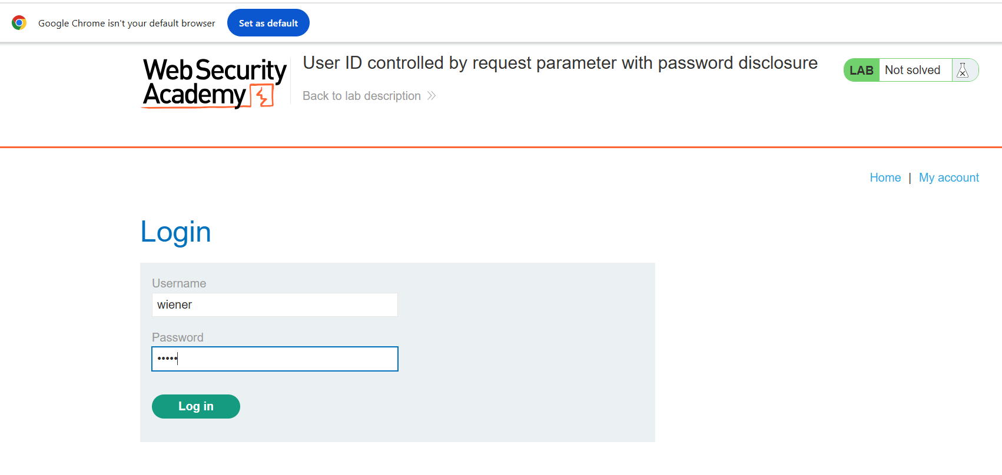

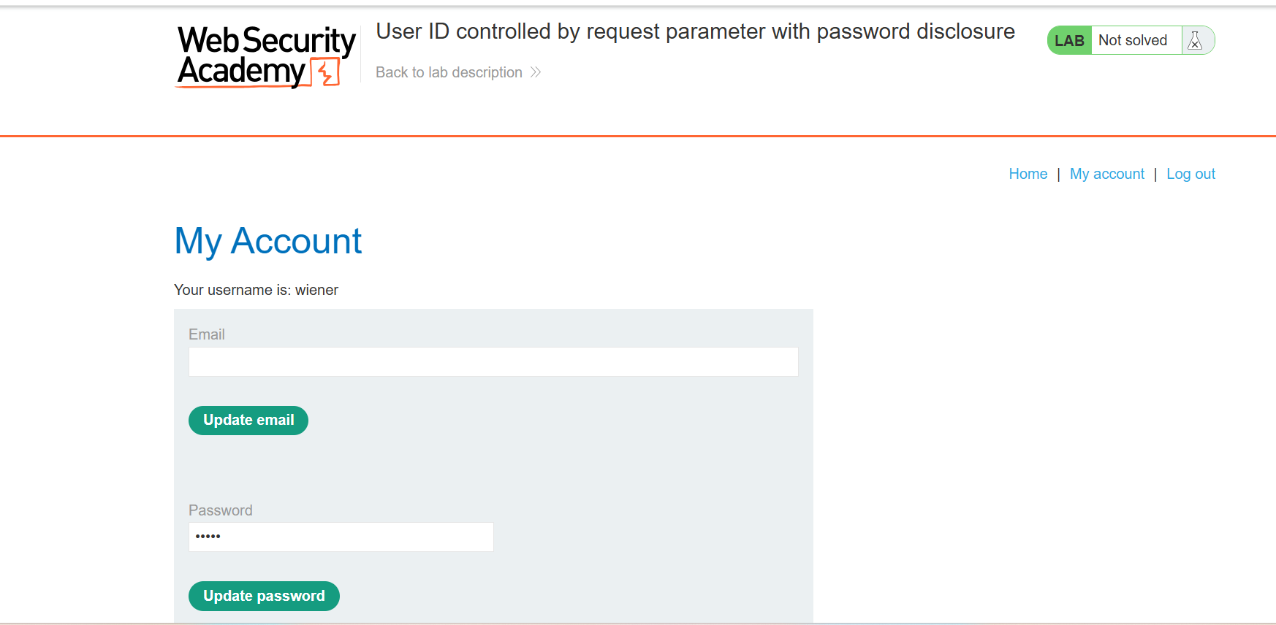

Step 2: Manipulate the User ID Parameter
Modify the account page URL and change the id parameter value to administrator.
Example:
/account?id=administrator
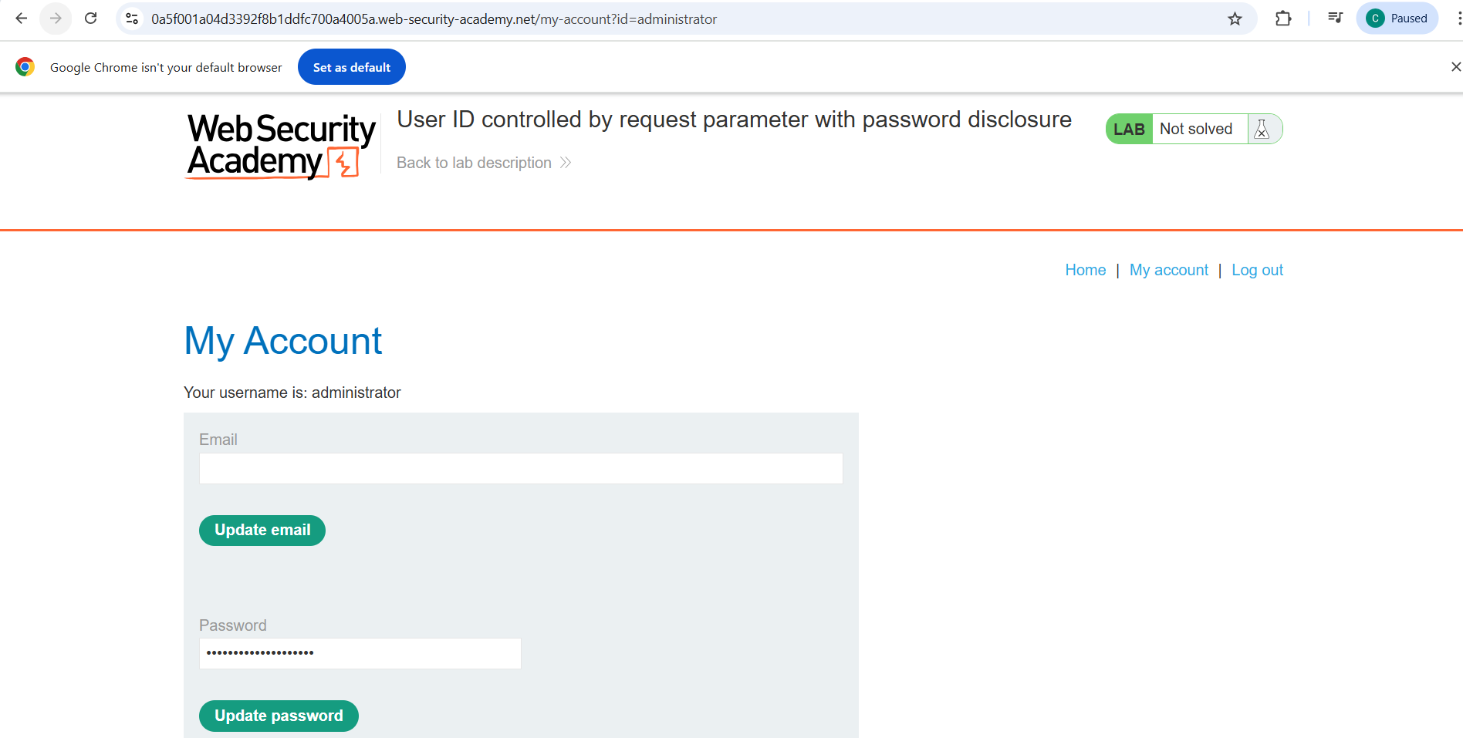

Step 3: Intercept the Response in Burp
Using inspect the HTTP response for the modified request. The response contains the administrator’s password embedded within a masked input field.
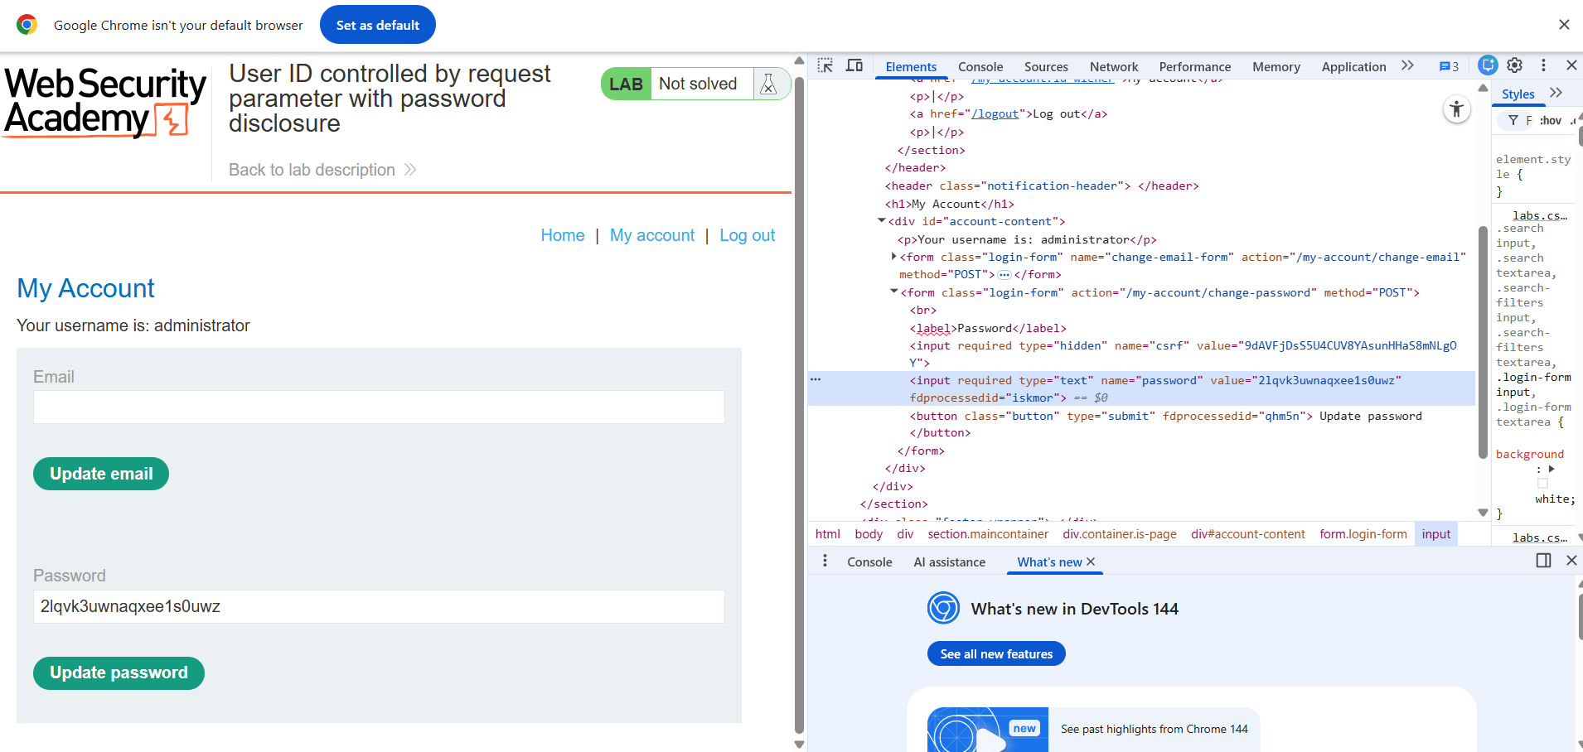

Step 4: Reveal the Password from the Masked Input
Inspect the HTML input field and change the input type from password to text, or directly copy the password value from the response.

Step 5: Log in as Administrator
Log out from the current session and log in using the retrieved administrator credentials.
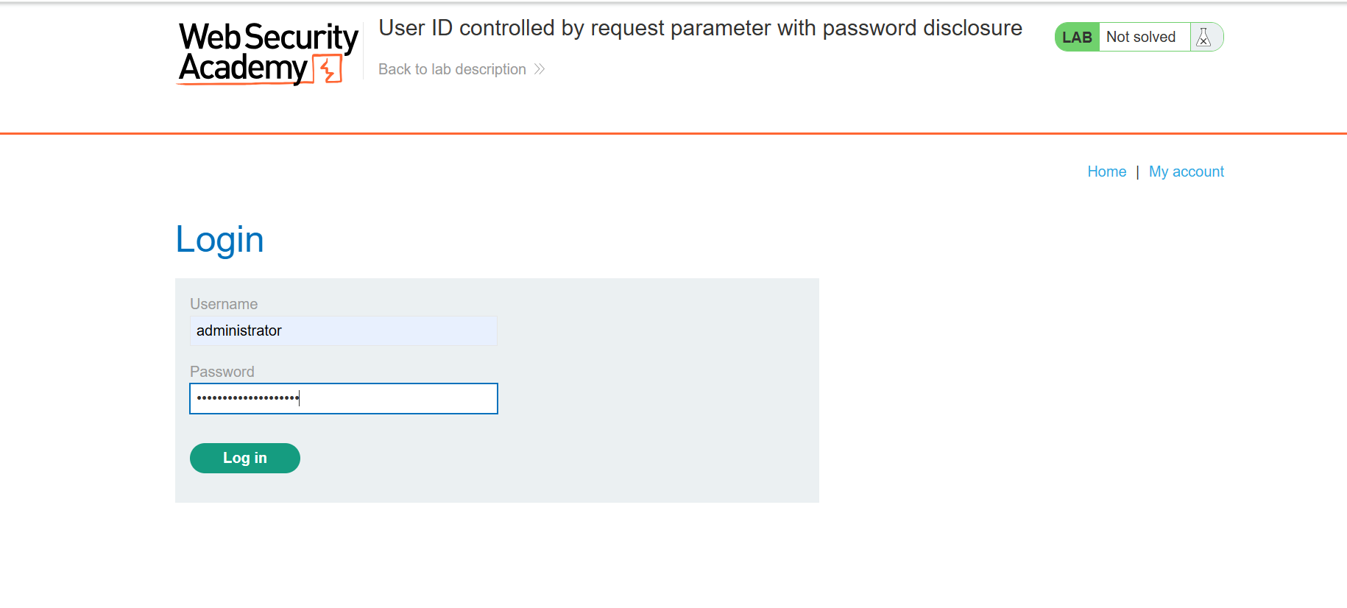

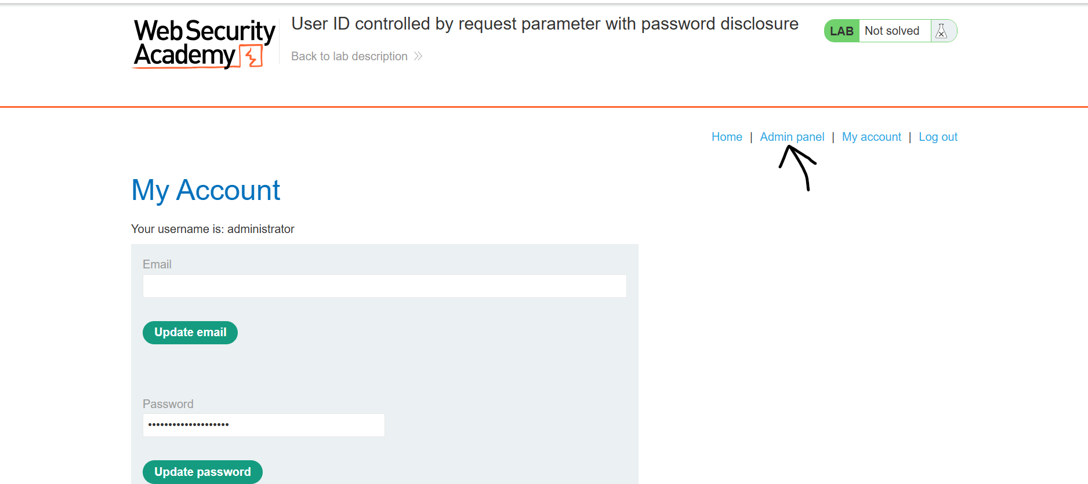

Step 6: Delete User Carlos
Access the admin panel and delete the user carlos to complete the lab.
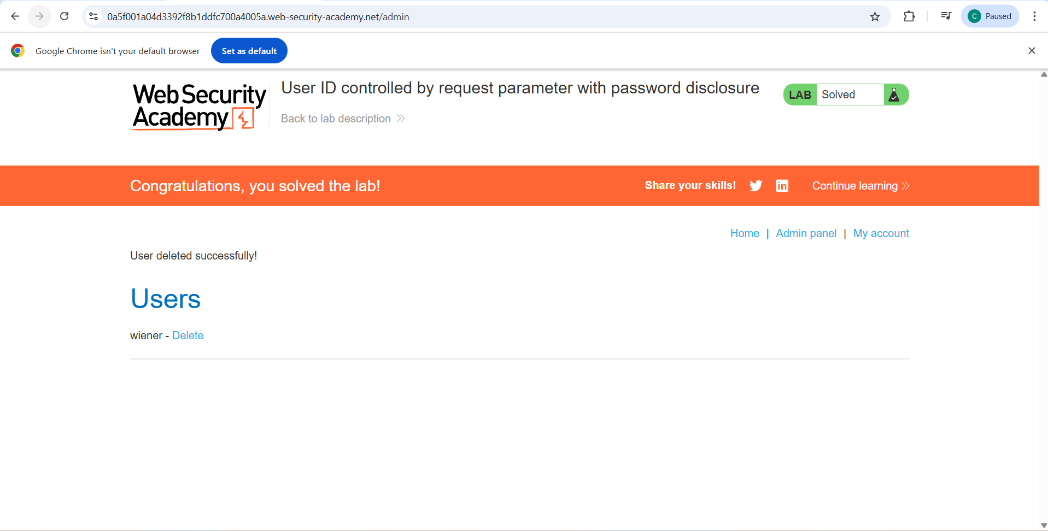

7. Impact Analysis
- Full administrator account compromise
- Exposure of plaintext passwords
- Unauthorized account deletion
- Complete loss of application integrity

8. Root Cause
- The application trusts user-controlled request parameters for authorization
- Passwords are stored and rendered in plaintext within HTML responses
- No server-side authorization validation is enforced

9. Mitigation & Recommendations
- Never prefill password fields with existing passwords
- Enforce strict server-side authorization checks
- Hash and salt passwords using strong algorithms (bcrypt, Argon2)
- Implement role-based access control (RBAC)

10. Conclusion
This lab highlights how IDOR vulnerabilities combined with poor credential handling can lead to complete system compromise. Passwords must never be exposed client-side, even in masked input fields.

11. References
- PortSwigger Web Security Academy – Access Control Labs
- OWASP Top 10 – Broken Access Control
- OWASP – Credential Management

12. Author
- Name: Chamika Jayasooriya
- Field: Cybersecurity / Penetration Testing

Repository Usage:
This document is suitable for GitHub portfolios, academic submissions, and cybersecurity internship showcases.

